1. ***Introduction***

*This section introduces the project idea, based on the created requirements, derived from both technical specification and personal motives. It introduces key concepts and background research, including current applications aimed at smartphone knowledge and learning of children between 9-12 (adolescent threshold).*

* 1. *Overview*

In 2017, 96% of Adults from the UK owned a mobile phone [1]; with 76% of adults owning a smartphone [2]. With the continued rise of smartphone use amongst individuals. The use of mobile phones has increased 1% from 2016-17, with a 5% increase in those whom own a smartphone. 87% of smartphone users admit to checking their phone within one hour of waking up [3], with 79% of users utilizing the smartphone at least one hour before going bed [4]

Based on the above figures, it is coherent to suggest the use of smartphones is likely to continue increasing. As such, the attempt to educate users on technologies contained within a smartphone seem only fit; given it be a daily part of our lives. Providing children at the threshold of adolescence the opportunity to understand the technologies confined provides not only the opportunity to use it to its full potential, but to understand its limits and safety liabilities.

The smartphone is a mere decade old, and every year it evolves in becoming an integrated part of everyday life.

* 1.2 Smartphone use amongst children

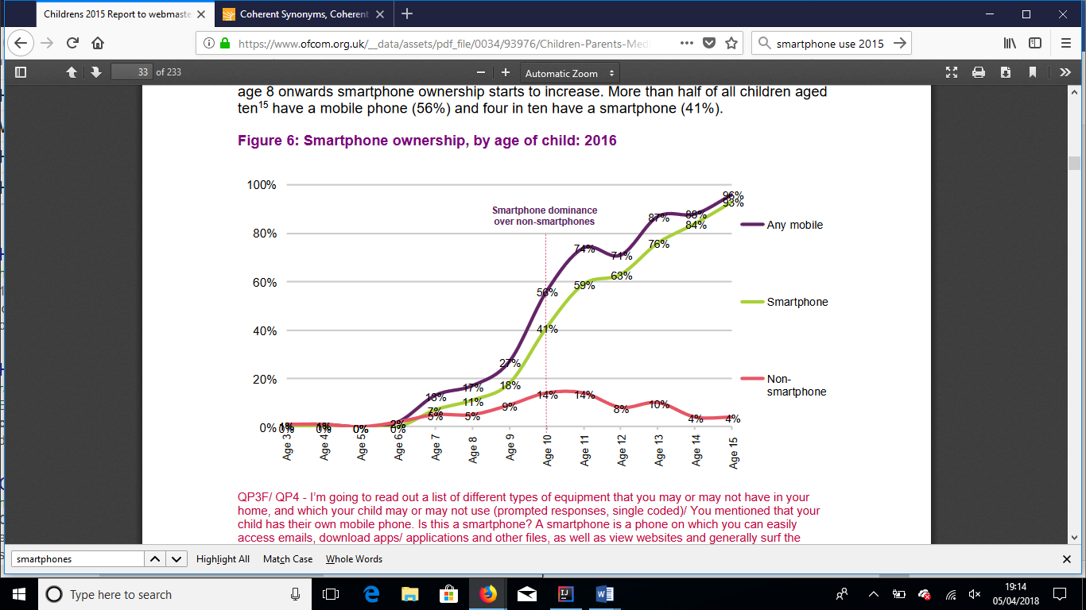

The above graph shows the use of smartphones amongst children within the United Kingdom. At aged 10, smartphone dominance overtakes non-smartphones dominance and by 15, just 5% of the 96% of children whom own a mobile phone currently own a non-smartphone.

Offering children, a guidance of the technologies used amongst smartphone in a fun, informative manner not only increase enjoyment; but provide safeguarding for users and future generations.

**Current Solutions**

There are currently a respectable number of resources that allow individuals to learn about smartphone technologies, shown below.

* gcllearnfree (a website that offers free online learning) offer guidance and support for mobile operating platforms such as android. Gcllearnfree offers different chapters and sections discussing the operation of the android system. Currently it does not offer any user interactions to and from its current structure. i.e, no interative smartphones.
* GSMarena (a website that offers mobile phone reviews, news and specification) offers sensor definitions in layman’s terms. GSMarena currently holds a massive amount of information on phone specification. It does not offer any information on how any technologies work, or any real time user interactions.
* HowStuffWorks (a website dedicated to offering guidance on how different technologies work) offers a breakdown of how smartphones work. HowstuffWorks discusses general principles, it discusses the difference between hardware and software; and some of the key components. Currently, no visual descriptions are given (i.e. images of components).

None of the current solutions aim to target the large group of individuals that transitions into the realm of smartphone dominance, and offers a more generalised approach of discussion, not catering to any individual age group. This project put great emphasis the need to cater this application to children whom begin to experience an era of smartphone dominance, and as such it is identified early on that it must meet the criteria that allows a prime phase of learning. In response, the application must be appealing such that the user stays engaged consistently. Secondly, it must offer a learning process that engages the four main parameters of the VARK model (Visual, Auditory, Reading/Writing and kinaesthetic). In response, the application will contain both Hardware and software, the physical process of engaging with the hardware (Visual/Kinaesthetic); consolidated with the software application (Auditory/Reading).

To ensure all users can engage to their maximum potential, special care will be taken to aid users with SLD (Specific learning Disabilities) including, Dyslexia, Dyspraxia, Auditory processing disorder and Visual Perceptual/Visual Motor Deficit. To achieve this, several objectives are met:

* The application must be tested with the approval and consent (from the responsible parent/guardian) of users with SLD.
* The application offers all descriptive items in both verbal and written context.
* Text sizes, font schemes and colours are all offered with full calibration set by the user.
* A quiz will be created that tracks user score. This data will be store securely on an SQL database and used to measure progress, as well as improve questions, and identify trends in knowledge of the smartphones technologies. The software will provide security from SQL injection through prepared statements.
* No personal information is stored about the user such that it can be directly linked to them at any time (Full name, Address, etc).

The learning process of children

The structure of this application is designed with the term ‘Learning through play’ in constant thought. A term used in education and psychology to describe how a child learns to make sense of the world around them, it’s defined as: ‘a context for learning through which children organise and make sense of their social worlds, as they engage actively with people, objects and representations’. The theory that children learn best through play is ever increasing; with japan, a country renowned for its childhood educational success, offering educational toys to children as a staple after its Meiji restoration. Play helps children build self-worth allowing them to feel good about themselves. As a result, children often become absorbed in what they are doing if the task is deemed fun; in turn, this helps them develop the ability to concentrate. The application will make use of learning through play by offering the context in a fun, creative manner. Children learn best with the use of vibrant; clear images. Basic, but thorough technological descriptions; and the freedom to navigate among the application at their own pace. Close attention to the VARK model will allow stimulant learning through the four main parameters. For examples, if a description is offered through a textual basis, it will also be offered narratively, with the hope of offering children of all learning process and abilities to have a thorough educational experience. Learning through play is also one of the primary educational tools used to engage children with SLD; often used in placement of textbooks, and other standardised materials. As this application will follow the LTP method, no alterations will be required for children with SLD; though enhancements of colour and text size will be available.

**Technicalities**

The use of this application will require the user to obtain specific software in order to operate it. Hardware will be required to fully explore the benefits of this application (an Arduino with the correct sensors, offered to the user at testing phase.) The machine running the application will require Java version of 8 or above and must offer a USB 2.0 or above connection. (Type C can be used with the user of an adapter). Java currently runs on over 3 billion devices and 1.1 Billion desktop devices, making it extremely accessible. Java applications run using the Java virtual machines. As a result, the operating system is abstracted behind the JVM, thus its renowned ability to WORA (Write once, run anywhere). Designing an application for children this is acknowledged as it increases the scope of users due to its accessibility. It is for these reasons that Java was chosen as the language for this application, being an extremely accessible platform, it allows the vast majority of pc owners to access the application, once made accessible online.

Security

As this application’s intended use is for those under the age of 18, Ethical process must be put in place to ensure the protection and safety of the user.

MySQL

The educational tool for robotics will use an SQL table to store users scores and nicknames, as such correct security measures must be put in place to ensure the protection of personal data and that confidentiality remains. As such, the SQL table used will not store any personal information. Names, will be replaced with nicknames allowing the user to identify themselves without having to provide any personal information. The database will require proper sanitation, with the user of prepared statements.

The users ‘Nickame’ and score a currently stored on a mySql database. MySQL operates as open source, and has a large community that help maintain, debug and upgrade it. The Database used in this application does not hold a large amount of data, and any DBMS (Database Management System) could have been used. MySQL is globally renowned for being the most secure DBMS and is used by many popular web applications, it also offers unmatched scalability due to its open source feature. If the applications were to be expanded globally, this would be high priority, it was for these reasons MySQL was chosen.

JAVA

At low level, Java byte code can be verified for the JVM (Java virtual machine) code conformance, ensuring code behaves correctly. Java is also type safe (operations that can be performed on data in the language are those sanctioned by the type of data), it’s Array and String indices are bounds checked (range checking, index checking etc) and fine-grained access control is built in. Though these measures are in place, Java is not inherently more secure than any other language. To ensure security standards are met, the development phase will take place using the CERT Secure coding standards as a refence point at all times.

JDK version

Using Java, one assumes many libraries are to be imported, and with the use of both JavaFX and an Arduino, ensuring a JDK that allowed all libraries to work competently was vital. Upon investigation the library that provides communication between and Arduino and the java language was only available in 32-bit format. Consequently, a 32-Bit JDK must be used. This limits serval features/classes introduced in JDK 9+. Though many of the additionalities are not needed, and those that offer value can be implemented else ways.

Development Environment

When choosing an IDE, three different environments were considered. NetBeans, which is offered upon downloading a JDK through oracle. Eclipse, a preferred favourite within Aberystwyth University; and intelliJ, a favourite amongst many Java programmers. Understanding early on that this project would be build using different machines, research into which IDE provided a unified interface for the version control system GitHub was accomplished. I had already experienced the functionality offered within InelliJ for git. This factor, along with intelliJ’s ability to provide faster coding due to it prediction system; It was considered the primary choice for this project. I note that IntelliJ as an IDE uses a much larger amount of memory than the latter IDE’s, had I used a machine that was limited on power, an alternative would have been used; however, of the two machines used to develop the application both had power enough to function with little to no memory issues.

Motivation

The aim of this project is to provide children with an application that allows them to understand some of the technologies they use every day, including both hardware and software. Identifying early on the potential they carry in the pocket, be it personal potential, education or social aspect that smartphones offer. But also, the security risks, the possible improper care. The application does not discuss any of these potentials in detail, but instead provides users with the ability to make tier own normed decisions from the knowledge they have gained.

The original project solution was an Educational tool for robotics. The intention was to create an application that educated children on some branch of robotics. This general idea was then build on, early on it was agreed that this project that target children between the ages on 9 and 12; with the suggestion it looked at technologies in smartphones. Identifying the sensors within smartphones was generated as a result of the above discussions and the project scope was formed.

Analysis

The Analysis for this project began with outlying requirements. Requirements were split into user stories, and these stories were then broken down into smaller, manageable ones. As this is a single user project, no information needed be passed amongst a team; saving considerable time. Weekly meetings with my supervisor identified potential flaws, and potential points to add value. This was considered the ‘Sprint Review’. During the sprint review, some issues were identified, as a result some functionally was changed at its final stage. This did not prove problematic; following the agile Manifesto, one of its four key points encourages “Responding to change, over following a plan”.

<http://files.acecqa.gov.au/files/National-Quality-Framework-Resources-Kit/belonging_being_and_becoming_the_early_years_learning_framework_for_australia.pdf> - play based learning definition

Human growth and the development of personality, Jack Kahn, S usan Elinor Wright,

Kathleen S. Uno, *Passages to Modernity: Motherhood, Childhood, and Social Reform in Early Twentieth Century Japan*